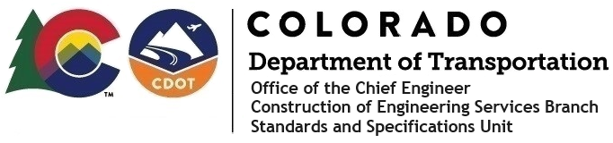

**Memorandum**

**Date**: September 11, 2025

**To**: All holders of Standard Special Provisions

**From**: Bill Cornelius, Standards and Specifications Unit Manager

**Subject**: New standard special provision: Revision of Section 106 Buy America (BA) and Build America Buy America (BABA) requirements – No Federal-Aid or Projects with less than $500,000 in Federal-Aid Highway Funding

As of September 11, 2025, this unit has issued the new standard special provision, Revision of Section 106 Buy America (BA) and Build America Buy America (BABA) requirements – No Federal-Aid or Projects with less than $500,000 in Federal-Aid Highway Funding, with 1 page, and dated September 11, 2025.

This provision is a modification to the existing standard special provision related to Buy America requirements for those projects with less than $500K in federal-aid highway. With the incorporation of the prior Buy America into the 2025 Standard Specifications book, which included the definitions section, definitions in the Standard Special are no longer needed as they are duplicated. The attached standard special provision deletes the definitions portion.

Please use this on all state-only funded (CDOT and Local Agency administered) Infrastructure projects that contain no federal-aid highway funding or those projects (CDOT and Local Agency) that contain less than $500,000 in federal-aid highway funding and have a federal funding Construction Phase authorization date that has occurred on or after October 23, 2023.

This standard special provision will become mandatory in projects advertised on or after October 1, 2025. You may use this standard special provision in projects advertised before this date.

For those of you who keep a book of Standard Special Provisions, please include this new provision. For your convenience, this provision and the latest SSP Index are attached to the email. You can also find these in our Construction Specifications web pages: [Standard Special Provisions](https://www.codot.gov/business/designsupport/cdot-construction-specifications/2025-construction-specifications) and the [Recently Issued Special Provisions.](https://www.codot.gov/business/designsupport/cdot-construction-specifications/2025-construction-specifications/recently-issued-special-provisions)

If you have any questions or comments, please contact this office.

2829 W. Howard Pl., 3rd Fl. Denver, CO 80204 P: (720) 766-0420 F: 303-757-9868 [www.codot.gov](https://www.codot.gov/)